Cruises in the Garden of Eden - 2012/3 Euro
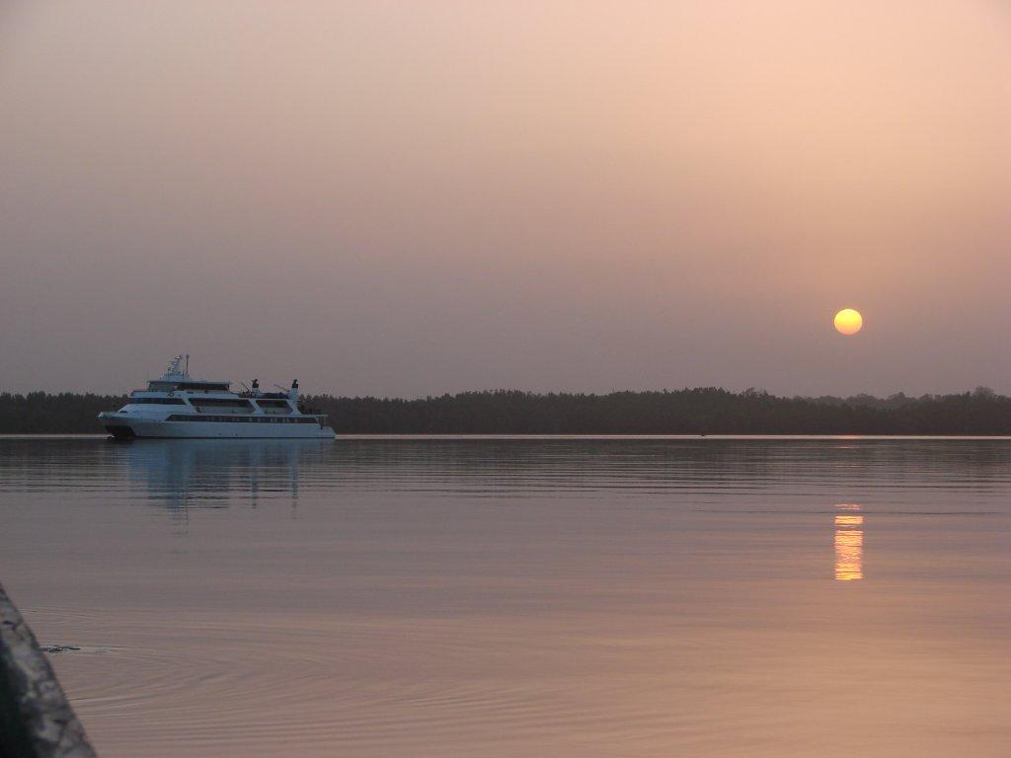

Discover Paradise in the Seychelles
3, 4 & 7 day cruises from Praslin or Mahe (Victoria)
on board the Motor Yacht Pegasus

The Amphition YachtingExperience
Discover the Seychelles the best way: By small ship. Hop from island to island in perfect harmony with this unspoilt paradise and visit islands which will capture your senses. Everywhere an amazing fauna and flora. Snorkel or dive and watch an amazing underwater world. Walk into centuries old rain forests with unique species of wild life and sight the rare black parrots, the world famous Coco de Mer palm trees or giant land tortoises.
The Motor yacht Pegasus
The twin-hulled Pegasus, built in 1990, completely refitted in the winter of 2012, accommodates up to 49 guests in a relaxed, congenial atmosphere. On board, you will enjoy magnificent sea views as you stroll our 2.500 square feet/240 m2 of open deck furnished with comfortable deck chairs or enjoy a delightful meal al fresco. You can relax with friends in the handsomely appointed lounge, browse in the well-stocked library or enjoy ocean-view dining in the convivial and spacious restaurant area. A platform on Pegasus stern enables you to swim when weather and anchorage conditions permit.
Life on Board
Life on board centres around the indoor/outdoor Lounge and its American Bar on Upper Deck. The adjoining dining area is surrounded by large windows providing beautiful views of the ports of call. It accommodates all guests at one single seating and provides a high standard of cuisine, always with some local flavour. Al fresco breakfast or dining is provided as a choice. The spacious Sun Deck is the ideal place to bask under the sun, read a good book or just gaze at the scenery. Service on board is provided by your Captain and his experienced marine and hotel crew members. It will be attentive or unobtrusive according to your requirements and priority is always given to the safety and comfort of passengers.
The Cabins
The 23 cabins of the PEGASUS are located on Sun Deck (3 cabins), Upper Deck (2 cabins), Main Deck (16 cabins) and on Lower Deck (2 cabins). They are large and comfortable, decorated with soft colour fabrics. The cabins are equipped with twin or queen size beds with two of the cabins being quadruples and 1 cabin being triple and they all have large windows (except for the 2 cabins of the Lower Deck which have portholes). All cabins offer en suite bathrooms with shower, TV/VCR units, music channels, hairdryers, individually controlled A/C and safe deposit boxes.

The 7 night / 8 day Seychelles Cruise
Mahe – Mahe / Saturdays
Day 1- Saturday
Mahe (Victoria) - Beau Vallon Bay
Embarkation 15:00 to 16:00 pm. After the Welcome cocktail and safety drill, we leave Port Victoria and sail north along Mahe Northern coast line to reach Beau Vallon Bay to spend the night. Welcome diner. Evening at anchor.

Day 2 - Sunday - Aride Anse Lazio, Praslin
We leave Mahe Island early in the morning to reach to Aride, a striking granite island north of Praslin. Unlike her name, the island has a dense vegetation and is home to colonies of birds. Our optional excursion will take you all the way to the top of the island for an amazing view of the island. The island is home to the Wright's gardenia found nowhere else on earth and to bird species like the Audubon's shearwater, the Seychelles warbler. In the afternoon we sail to Anse Lazio, Praslin, one of the most beautiful beaches in the world. Time for water sports, snorkelling or optional diving. Evening at anchor.

Day 3 - Monday - Cousin Island - Curieuse
This morning we leave Mahe and sail to Cousin Island. Optional excursion to the Bird Sanctuary which is in the care Bird Life International. A quarter million birds breed on Cousin which also has several nesting beaches for turtles. In the afternoon we sail to Curieuse Island. Overnight at anchor.

Day 4- Tuesday
Curieuse
This morning we visit this uninhabited island, once a leper colony and home to giant tortoises. Our walking excursion with a park guide will bring us to the farm, along mangrove forests. BBQ on the beach. Water sports. Creole night.

Day 5- Wednesday
Praslin – Baie St. Anne or Anse Possession
This morning we leave Curieuse and reach Praslin, Baie St Anne or Anse Possession. We disembark for an optional excursion to the famous Vallee de Mai Reserve, a World Heritage site. You will explore the pathways under tall palm trees which produce the famous Coco de Mer and you might sight a black parrot only found in Praslin. Afternoon at leisure for snorkelling or optional diving excursions.

Day 6- Thursday
Sister Islands / Coco Island - La Digue
This morning we reach Sister Islands or Coco Island, all uninhabited and offering great snorkelling in crystal clear waters. After lunch we arrive in La Digue, a quiet island community where time is standing still: No cars, just bicycles and oxcarts. Our optional oxcart tour will take us to the picturesque Anse de Source d’ Argent for a sunset swim. It is said that this is the most photographed beach in the world.

Day 7- Friday
La Digue – St. Anne Island
After a lazy morning in La Digue we sail back towards Mahe and reach St. Anne Island. There is a last opportunity for snorkelling and swimming before our farewell Captain's Dinner. Later in the evening we reach Port Victoria.

Day 8- Saturday - Mahe (Victoria)
Disembarkation at 9:00 am

The 4 night / 5 day Seychelles Cruise
Mahe - Praslin - Saturdays to Wednesdays

Day 1- Saturday
Mahe (Victoria) - Beau Vallon Bay
Embarkation 15:00 to 16:00 pm. After the Welcome cocktail and safety drill, we leave Port Victoria and sail north along Mahe Northern coast line to reach Beau Vallon Bay to spend the night. Welcome diner. Evening at anchor.

Day 2 - Sunday - Aride Anse Lazio, Praslin

We leave Mahe Island early in the morning to reach to Aride, a striking granite island north of Praslin. Unlike her name, the island has a dense vegetation and is home to colonies of birds. Our optional excursion will take you all the way to the top of the island for an amazing view of the island. The island is home to the Wright's gardenia found nowhere else on earth and to bird species like the Audubon's shearwater, the Seychelles warbler. In the afternoon we sail to Anse Lazio, Praslin, one of the most beautiful beaches in the world. Time for water sports, snorkelling or optional diving. Evening at anchor.

Day 3 - Monday - Cousin Island - Curieuse

This morning we leave Mahe and sail to Cousin Island. Optional excursion to the Bird Sanctuary which is in the care Bird Life International. A quarter million birds breed on Cousin which also has several nesting beaches for turtles. In the afternoon we sail to Curieuse Island. Overnight at anchor

Day 4- Tuesday - Curieuse

This morning we visit this uninhabited island, once a leper colony and home to giant tortoises. Our walking excursion with a park guide will bring us to the farm, along mangrove forests. BBQ on the beach. Water sports. Creole night.

Day 5- Wednesday - Praslin – Baie St. Anne or Anse Possession

This morning we leave Curieuse and reach Praslin, Baie St. Anne or Anse Possession. Disembarkation at 9:00 am.
The 3 night / 4 day Seychelles Cruise
Praslin – Mahe - Wednesdays to Saturdays

Day 1 - Wednesday Praslin – Baie St. Anne or Anse Possession
Embarkation 4 pm. Overnight at anchor.

Day 2- Thursday - Sister Islands/Coco Island - La Digue

This morning we reach Sister Islands or Coco Island, all uninhabited and offering great snorkelling in crystal clear waters. After lunch we arrive in La Digue, a quiet island community where time is standing still: No cars, just bicycles and oxcarts. Our optional oxcart tour will take us to the picturesque Anse de Source d’ Argent for a sunset swim. It is said that this is the most photographed beach in the world.

Day 3- Friday - La Digue – St. Anne Island

After a lazy morning in La Digue we sail back towards Mahe and reach St. Anne Island. There is a last opportunity for snorkelling and swimming before our farewell Captain's Dinner. Later in the evening we reach Port Victoria.

Day 4- Saturday - Mahe (Victoria) Disembarkation at 9:00 am
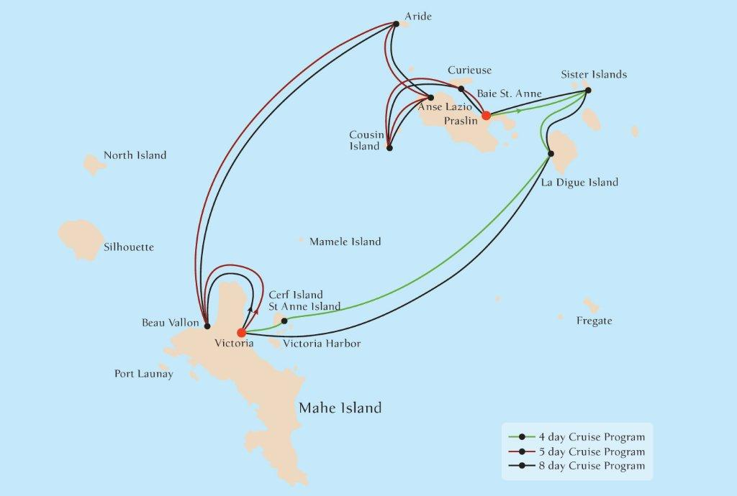

Itineraries can be changed at the discretion of Amphition Yachtingand of the Vessel's Captain in case of adverse weather conditions - winds of 6/7 beaufort or more depending on the vessel- on port authorities not allowing a vessel to leave port or in case of other extraordinary conditions. Such itinerary changes do not entitle automatically passengers to any refunds but Amphition Yachtingguarantees that passengers are disembarked at the advertised port of disembarkation on time for their flights.

THE SEYCHELLES CRUISES -2012/13

8 DAY/7 NIGHT CRUISES MAHE - MAHE
On board the M/Y PEGASUS
OFFICIAL € EURO RATES

FROM MAHE  Saturday Sailings  CABIN CATEGORIES | Season C | Season B | Season A
Cat C  Lower and Main Deck- Double or Twin Beds | € 1.350 | € 1,490 | € 1,690
Cat B  Main and Sun Deck- Double or Twin Beds | € 1.500 | € 1,690 | € 1,890
Cat A  Main and Upper Deck- Double or Twin Beds | € 1.800 | € 1,990 | € 2,190
Reduction for 3rd person in Cat A | 30% | 30% | 30%
Single Supplement | 30% | 30% | 30%
Conservation & other Charges | € 210 | € 210 | € 210

SEASON C | 2012  December: 15  2013  January: 5, 12, 19  April: 6  December: 7, 14
SEASON B | 2013  January :26  February : 2, 9, 16, 23  March : 2, 9, 16  April:13, 20, 27  May: 4, 11, 18, 25  June: 1, 8, 15, 22, 29  July: 6, 13, 20, 27  August: 3, 10, 17, 24, 31  September: 7, 14, 21, 28  October : 5, 12, 19, 26  November: 2, 9, 16, 23, 30
SEASON A | 2012  December: 22, 29  2013  March 23, 30  December : 21, 28

THE SEYCHELLES CRUISES -2012/13

5 DAY/4 NIGHT CRUISES MAHE - PRASLIN
On board the M/Y PEGASUS

OFFICIAL € EURO RATES

FROM MAHE  Saturday Sailings  CABIN CATEGORIES | Season C | Season B | Season A
Cat C  Lower and Main Deck- Double or Twin Beds | € 850 | € 950 | --------
Cat B  Main and Sun Deck- Double or Twin Beds | € 990 | € 1,100 | --------
Cat A  Main and Upper Deck- Double or Twin Beds | € 1,100 | € 1,250 | --------
Reduction for 3rd person in Cat A | 30% | 30% | --------
Single Supplement | 30% | 30% | --------
Conservation & other Charges | € 140 | € 140 | --------

SEASON C | 2012  December: 15  2013  January: 5, 12, 19  April: 6  December: 7, 14
SEASON B | 2013  January :26  February : 2, 9, 16, 23  March : 2, 9, 16  April:13, 20, 27  May: 4, 11, 18, 25  June: 1, 8, 15, 22, 29  July: 6, 13, 20, 27  August: 3, 10, 17, 24, 31  September: 7, 14, 21, 28  October : 5, 12, 19, 26  November: 2, 9, 16, 23, 30
SEASON A | Not Available

THE SEYCHELLES CRUISES -2012/13

4 DAY / 3 NIGHT CRUISES PRASLIN - MAHE
On board the M/Y PEGASUS
OFFICIAL € EURO RATES

FROM PRASLIN  Wednesday Sailings  CABIN CATEGORIES | Season C | Season B | Season A
Cat C  Lower and Main Deck- Double or Twin Beds | € 670 | € 750 | --------
Cat B  Main and Sun Deck- Double or Twin Beds | € 760 | € 850 | --------
Cat A  Main and Upper Deck- Double or Twin Beds | € 950 | € 1,050 | --------
Reduction for 3rd person in Cat A | 30% | 30% | --------
Single Supplement | 30% | 30% | --------
Conservation & other Charges | € 110 | € 110 | --------

SEASON C | 2012  December : 19  2013  January: 9, 16, 23  April: 10  December: 11, 18
SEASON B | 2013  January: 30  February: 6, 13, 20, 27  March: 6, 13, 20  April : 17, 24  May: 1, 8, 15, 22, 29  June: 5, 12, 19, 26  July: 3, 10, 17, 24, 31  August : 7, 14, 21, 28  September: 4, 11, 18, 25  October: 2, 9, 16, 23, 30  November: 6, 13, 20, 27  December : 4
SEASON A | Not Available

HONEYMOON PACKAGE – DESCRIPTION, CONDITIONS AND RESTRICTIONS

1/The Honeymooners Package features:

- 25 % reduction for the bride
- Cabins with Double or King bed
- Welcome Honeymooners treatment including a Complimentary bottle of Champagne and a Fruit Basket;
- A Candle Lit Dinner at our Special Honeymooners location on board our ships (for all our programs outside Greece ) or at a preferred restaurant in Santorini or Mikonos for our Greek cruise programs;
- 10% discount for any wedding anniversary on board our ships;
- Automatic access to our Variety Club membership;
- “ Our Memories” gift at disembarkation;
- A free 1/2 hour massage for 2, if on board our Harmony V, Variety Voyager and Seychelles program vessel.

NOTES

1. Please ask the details for our "Wedding and Cruise with friends and family" private charter for 40 to 72 guests.
2. This package is also available to clients wishing to renew their vows. The Vows renewal ceremony is performed by our Ship Captains.

2/ Honeymoon offers : General conditions and restrictions

a/ The Honeymoon offer is valid only provided that the couple is traveling within 6 months from their wedding date (copy of marriage certificate required);

b/ The Package cannot be combined with any existing or future SPECIAL OFFERS.

CRUISE FARES CONDITIONS & RESTRICTIONS

1/ Cruise fares are per person and week and include:
- Accommodation in double or twin cabins with private SH/WC & air conditioning.
- Full-board: American buffet breakfast and two main meals daily, including a Welcome Cocktail, a Creole Night, fun BBQ (weather permitting) and Captain’s Dinner.
- Regular (filter) coffee, tea and still mineral water free all day.
- Use of fishing and snorkelling equipment.
- Multilingual Cruise Escort.

Not included:
- Beverages (except those mentioned above).
- Shore excursions on the islands or other land arrangements.
- Crew tips.
- Passenger personal expenses.

2/ Conditions and restrictions

PROOFREADING Tour Operators featuring our Cruises in their Catalogue or Internet site by itinerary, vessel’s description and images, will send VARIETY CRUISES a draft for error-checking of the contents prior publication as well as two brochure copies when printed. In order to secure corect information given to our clients and keep our high customer satisfaction levels. Amphition Yachtingwill not bare any responsibility for innacurate information or misrepresentation of our vessels or cruise itineraries without having accepted a draft prior to the brochure going to print or internet page published.

PAYMENT 25% deposit is required upon confirmation. Balance of payment is due no less than 60 days prior to day of embarkation.

CHILD REDUCTION Children between the ages of 7-10 sharing a cabin with two paying adults receive a 50% discount. Children between the ages of 10-16 sharing a cabin with two paying adults receive a 35% discount. Port taxes are not discounted.

CANCELLATIONS 25% of the cruise for any written cancellation received between 60 to 31 days prior to sailing; 50% up to 16 days prior to sailing; full cruise fare for written cancellations received less than the 16th day prior to sailing or for “no shows” even if cancellation is due to unforeseen circumstances beyond passenger’s control. Cancellations must be confirmed by AMPHITION YACHTINGin writing in all cases.

AMENDMENTS There may be a charge for amendments of cruise date or
decreasing guest numbers received less than 60 days prior to sailing. Amendments
must be confirmed by AMPHITION YACHTINGin writing.

NOT INCLUDED IN CRUISE FARE Such personal expenses as drinks (other than included in the rate), laundry and gratuities, (gratuities are optional but as a rule, satisfied clients are
expected to give to the captain, at the end of the cruise, approximately Euro 8.00-10.00 p/p p/day for distribution among crew members) medical expenses, port taxes, shore excursions (shore excursions are proposed and arranged on board by the tour leaders) expenditures incurred ashore, and anything not mentioned in cruise program.

